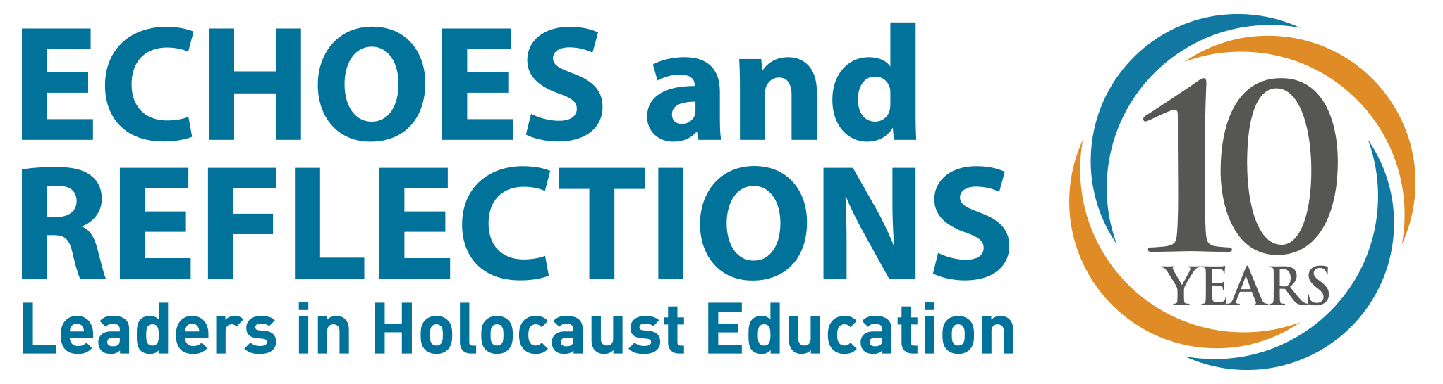
USC Shoah Foundation: Josh Grossberg 213-740-6065
josh.grossberg@usc.edu
Rob Kuznia 213-740-0965
rkuznia@usc.edu

ADL: Todd Gutnick 212-885-7755

adlmedia@adl.org

Yad Vashem: Estee Yaari

(Israel) 011-972-2-644-3412

estee.yaari@yadvashem.org.il

FOR IMMEDIATE RELEASE

Echoes and Reflections Marks
10 Years as a Leader in Holocaust Education
Los Angeles, March 26, 2015 – Echoes and Reflections, a comprehensive Holocaust education program that provides professional development and an array of resources for middle and high school teachers, is marking its 10th anniversary in 2015 with a strong trail of success behind it and ambitious goals for the future.
A unique partnership of the Anti-Defamation League, USC Shoah Foundation – The Institute for Visual History and Education, and Yad Vashem, and supported by Dana and Yossie Hollander, Echoes and Reflections has reached more than 25,000 educators and community leaders in all 50 states, in 6,000 public and 2,000 private schools since its launch in 2005. These educators can impact an estimated 3.5 million students in a given school year.
“We couldn’t be happier with how well Echoes and Reflections has been received,” said USC Shoah Foundation Executive Director Stephen Smith. “It’s not always easy teaching about the Holocaust, but it’s important that young people understand this history. As we enter our second decade, we will continue to make this valuable program available to as many educators as possible.”
The dynamic program prepares educators to teach about the Holocaust in a way that stimulates engagement and critical thinking. Rich with testimony clips from 52 Holocaust survivors, rescuers, and American liberators, the Echoes and Reflections Teacher’s Resource Guide is divided into 10 parts, with each segment exploring major themes associated with the Holocaust, including anti-Semitism, Nazi Germany, the ghettos, the “Final Solution” and resistance. To supplement its print material, in 2014 Echoes and Reflections launched a new website that offers classroom-ready content and primary sources to make teaching the subject matter even easier. Additionally, educators are connected to USC Shoah Foundation’s IWitness platform that offers more than 1,300 additional video testimonies, multimedia activities and digital resources.
“For the past 10 years, Echoes and Reflections has provided the opportunity for the three partners to collectively contribute to the teaching of the Holocaust in the United States, each offering their distinct expertise,” notes Yad Vashem’s Chairman Avner Shalev, “Through the very carefully constructed materials, teachers provide the important text and context for students to increase their knowledge of this watershed event and to make meaningful personal connections.”
This approach has informed the program since inception. Beth Dotan, former Executive Director of the Institute for Holocaust Education in Omaha in 2005, was the trainer for the first Echoes and Reflections program. “Echoes started when many of us were starting to think about, ‘How do we teach the Holocaust in a comprehensive way, in a way that draws questions, and uses materials from a number of different places? The partners provided this magical program for educators that made them understand that they couldn’t just teach what they thought the Holocaust was about; it had to be something different.”
Echoes and Reflections received the National Association for Multicultural Education National Media Award in 2007.
As Abraham H. Foxman, National Director of the Anti-Defamation League explains, “Our goal then – and now – is to ensure that the history of the Holocaust is not only taught by more teachers– but taught with deeper meaning. Faced with the frightening rise of anti-Semitism, intolerance, and violence around the world, helping young people understand this history and its universal lessons to the world today is critical.”
Independent tests show the value of Echoes and Reflections. A study conducted by CRESST in 2013 with over 300 educators found that educators praised the program’s versatility and its positive outcomes for students, indicating a significant increase in student knowledge (94 percent), interest (86 percent), and connection to the content (90 percent) as well as a reported 87 percent improvement in how students perceive and treat others.
The program already has more than 150 professional development programs scheduled for 2015, including its first in North Dakota. In almost all cases, Echoes and Reflections is offered free of charge to educators, and every participant receives a complimentary copy of the Teacher’s Resource Guide. Offerings range from three to six hours in length. For a complete list of upcoming programs, visit http://echoesandreflections.org/events
As part of its commemorative activities, Echoes and Reflections has invited participating educators to share their experiences with the material and the impact on their students. More information can be found at http://echoesandreflections.org
###
About the Anti-Defamation League (ADL)
The Anti-Defamation League was founded in 1913 “to stop the defamation of the Jewish people and to secure justice and fair treatment to all.” Now the nation’s premier civil rights/human relations agency fighting anti-Semitism and all forms of bigotry, ADL defends democratic ideals and protects civil rights for all. A leader in the development of materials, programs, and services, ADL builds bridges of communication, understanding, and respect among diverse groups in the United States and around the world, carrying out its mission through a network of Regional and Satellite Offices in the United States, as well as offices abroad.

About USC Shoah Foundation
USC Shoah Foundation — The Institute for Visual History and Education is dedicated to making audio- visual interviews with survivors and other witnesses of the Holocaust and other genocides, a compelling voice for education and action. The Institute’s current collection of more than 53,000 eyewitness testimonies contained within its Visual History Archive preserves history as told by the people who lived it, and lived through it. Housed at the University of Southern California, within the Dana and David Dornsife College of Letters, Arts and Sciences, the Institute works with partners around the world to advance scholarship and research, to provide resources and online tools for educators, and to disseminate the testimonies for educational purposes.

About Yad Vashem
Established in 1953, Yad Vashem, the Jewish people’s living memorial to the Shoah, is dedicated to education, documentation, research and commemoration of the Holocaust. Drawing on the memories of the past, Yad Vashem aims to strengthen commitment to protect the basic human values that were undermined during the Holocaust. Through its International School, Yad Vashem sets the global standard for Holocaust education and has accrued vast worldwide experience creating curricula, working with educators and young leaders, and building a sound pedagogical philosophy that serves as the foundation for compelling and relevant Holocaust education.

