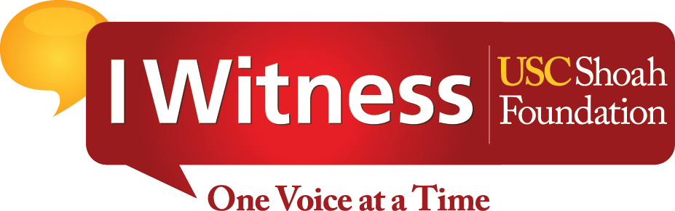

IWITNESS EDUCATIONAL WEBSITE COMES OUT OF BETA WITH ENHANCED FUNCTIONALITY, NEW PROJECTS AND QUICKER ACCESS

Developed by USC Shoah Foundation, IWitness has been shown to improve critical-thinking skills, while also increasing students’ ability to engage the world with heightened sense of responsibility, empathy and tolerance.

After a successful test run, the educational website IWitness is coming out of beta with new functionality, additional languages, as well as a faster and easier way for educators to create accounts so they can begin using IWitness in their classrooms without delay.

The upgrade comes as an analysis proves that IWitness is an effective way to teach students how to become more responsible, tolerant and empathetic. It has also been shown to increase critical-thinking skills and a young person’s willingness to engage with others in productive and helpful ways.

Now used in all 50 states and 58 countries, IWitness was developed by USC Shoah Foundation – The Institute for Visual History and Education to connect secondary school students with the audio-visual testimonies of survivors and witnesses of the Holocaust and other genocides in its Visual History Archive to motivate them to do their part to build a better world.

The results speak for themselves.

According to research, students reported up to a 28 percent increase in an interest in helping others after they engaged with IWitness. They also reported a 30 percent improvement in their critical thinking skills. In all, 72 percent of students surveyed said they benefitted from using IWitness.

And now, IWitness is even more comprehensive. New testimonies have been added in several languages, including Dutch, French and Ukrainian, bringing the total number of languages to 15, so students across the world can take part in activities. Added functionality allows teachers to copy and share activities with each other, and a one-step registration gives educators instant access to the many multimedia activities and learning opportunities IWitness offers.

These new features were added after an extensive evaluation process that looked at how well IWitness was being received in its beta phase.

Developed especially for the classroom, IWitness is a unique primary source that connects students with contextualized first-person views of history. It provides teachers with an array of student-centered activities designed to engage multiple literacies, across disciplines from civics, government and history to poetry, art and ethics, educators can tailor lessons appropriate for their classrooms.

IWitness is designed to align with Common Core standards and was named as one of the “Top 25 Websites for Teaching and Learning” by the American Association of School Librarians in 2012.

For their part, students who engage in this transformative-learning experience will do far more than watch and listen. IWitness encourages them to research, explore, reflect and respond with their own voices about why voices from the past continue to matter.

Students have access to the testimonies of nearly 1,500 survivors and other witnesses to the Holocaust and other genocides. The testimonies are searchable by more than 9,000 keywords, enabling learners to pinpoint exact moments of interest. Using the built-in editor, students can construct video essays, with video, maps, photos and music.

To learn more about IWitness, visit iwitness.usc.edu

###

About the Shoah Foundation
USC Shoah Foundation - The Institute for Visual History and Education is dedicated to making audiovisual interviews with survivors and other witnesses of the Holocaust and other genocides, a compelling voice for education and action. The Institute's current collection of more than 53,000 eyewitness testimonies contained within its Visual History Archive preserves history as told by the people who lived it, and lived through it. Housed at the University of Southern California, within the Dana and David Dornsife College of Letters, Arts and Sciences, the Institute works with partners around the world to advance scholarship and research, to provide resources and online tools for educators, and to disseminate the testimonies for educational purposes.
Contact:
Anne Marie Stein / Josh Grossberg
USC Shoah Foundation
213.740.6036 / 213.740.6065
amstein@usc.edu / josh.grossberg@usc.edu

