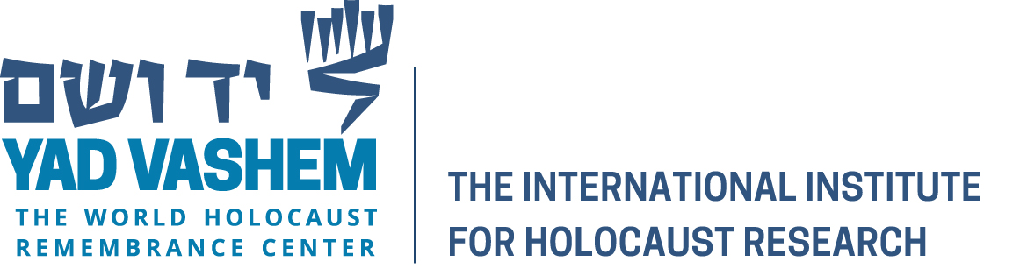



APPLICATION FORM

Location: Yad Vashem, Jerusalem, Israel, 25- 29 June 2017

Submission Deadline: 15 March 2017

PERSONAL INFORMATION

O Mr. O Ms.

Last Name First Name

Place of Birth Date of Birth

O Male O Female

Country of Citizenship _____________

ADDRESS

Home Address

Tel. No. Fax No.

Email Address

EDUCATIONAL HISTORY

Number of Years Already in the PhD Program _________

Expected Date of Thesis Completion ___________

Name of University/College Where Presently Enrolled

Academic Department

Address

Title of Thesis

COURSEWORK COMPLETED (if applicable): Yes______ No______

PUBLICATIONS, ACADEMIC AWARDS, SCHOLASTIC HONORS

REFERENCE

Thesis Advisor

Name

Postal Address

Email

An application consists of:

- A completed application form
- One-page abstract
Please include: A general description, one’s methodology and approach, and a listing of primary material already analyzed
- Recommendation letter from the PhD advisor
- List of Yad Vashem archival holdings sources relevant for one PhD
- Short academic biography (15-20 lines)

Please send all application materials to:
eliot.nidam@yadvashem.org.il; cagr@usc.edu

