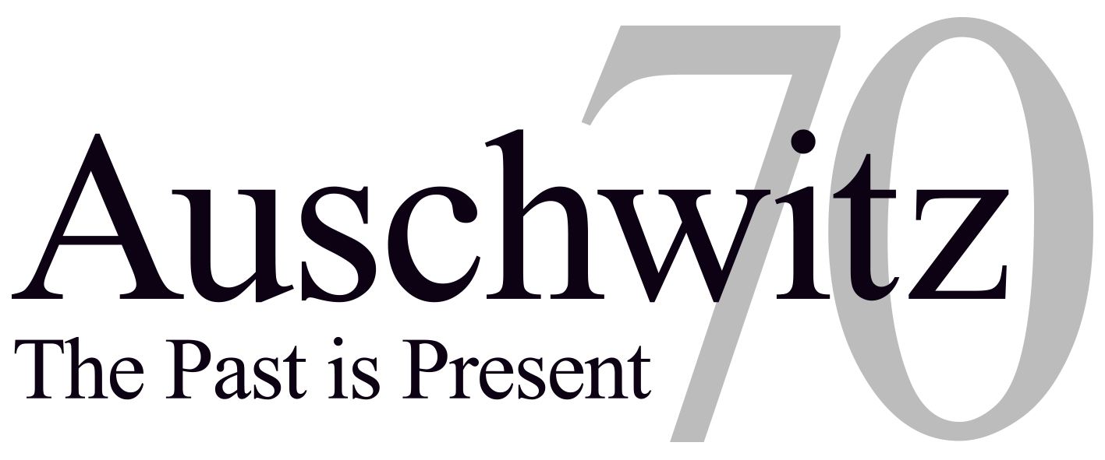

AUSCHWITZ: THE PAST IS PRESENT ANNOUNCES COMMITTEE MEMBERS

Program by Auschwitz-Birkenau State Museum, USC Shoah Foundation and World Jewish Congress in partnership with Discovery Education

LOS ANGELES, Dec. 4, 2014 - Leading American and international businessmen and philanthropists are joining forces to support the commemoration of the 70th anniversary of the liberation of the Nazi death camp Auschwitz-Birkenau on 27 January 2015, which will be organized by the Auschwitz-Birkenau State Museum and the International Auschwitz Council in partnership with the USC Shoah Foundation – The Institute for Visual History and Education and the World Jewish Congress.

The committee will be chaired by David Zaslav, president and chief executive officer of Discovery Communications. Members of the Leadership Circle of Auschwitz: The Past is Present include (in alphabetical order) Len Blavatnik, founder and chairman of Access Industries, Joel Citron, managing director and co-chief executive officer of Tenth Avenue Holdings, Stephen A. Cozen, founder and chairman of Cozen O’Connor, Ronald S. Lauder, president of World Jewish Congress, Yuri Milner, founder of DST Global, Haim Saban, chairman and chief executive officer of Saban Capital Group, Howard Schultz, chairman, president and chief executive officer of Starbucks Coffee Company and Steven Spielberg, founder of USC Shoah Foundation.

Other members of the committee include Barry Diller, Ari Emanuel, David Geffen, Jeffrey Katzenberg, Ron Meyer, Leslie Moonves, Eric Schmidt, Diane Von Furstenberg, Harvey Weinstein, Rob Wiesenthal and Jeff Zucker.

Auschwitz: The Past is Present has announced its first two programs, an education initiative in partnership with Discovery Education, and the Witness Travel Program, an initiative run by the World Jewish Congress that will bring 100 survivors of Auschwitz to be honored guests at the 70th anniversary commemoration.

The education initiative of Auschwitz: The Past is Present will reach thousands of teachers and bring 25 educators from across the world to participate in a four-day professional development experience in Warsaw, Krakow, and at Auschwitz II-Birkenau, exploring the theme “The Past is Present” through site visits, seminars, and hands-on workshops with witness testimony.

The trip promises to deepen teachers’ understanding of the history and continued importance of preserving the historic German Nazi concentration and extermination camp, as well as the testimonies of those who survived the atrocities that occurred there during World War II. The program will encourage teachers to develop digital and media literacies through USC Shoah Foundation’s multimedia learning platform IWitness, including newly developed resources to teach the story of Auschwitz distributed via Discovery Education.

“Auschwitz: The Past is Present committee is supporting programming to engage a new generation in awareness, remembrance and community building,” said Stephen Smith, executive director of USC Shoah Foundation. “Those who survived Auschwitz have carried the heavy burden of remembering. It’s up to us now, their children and grandchildren, to lift this heavy weight off their shoulders. We are ready to take on the responsibility of ensuring that this tragic chapter of human history is never repeated.”

“We want to make a clear statement that the 70th anniversary won’t be the same as previous anniversaries,” said Piotr M.A. Cywiński, director of the Auschwitz Museum. “It’s the last round anniversary to be commemorated in the presence of a large group of survivors. Until now, it has been the survivors who have taught us how to look at the tragedy of the victims of the Third Reich and the total destruction of the world of European Jews. Their voices have become the most important warning against the human capacity for extreme humiliation, contempt and genocide.”

Information on other programs of Auschwitz: The Past is Present will be announced soon.

Keeping the voices of survivors strong has been the central mission of USC Shoah Foundation, which has 53,000 audio-visual testimonies from Holocaust survivors in its Visual History Archive.

